*San Francisco Bay-Delta Priority Ecosystems Science Concept Proposal FY19 (submitted July 2018)*

*1. Title:* **Understanding How Invasive Aquatic Vegetation Alters Phytoplantkon Community Abundance and Species Composition and Impacts the Pelagic Foodweb**

*2. Focus Area(s):* Addressing the multi-stressor problem

*3. Concept*

The increase in the abundance and distribution of invasive floating and submerged aquatic vegetation (macrophytes) in the Delta is of growing concern due to issues for navigation and water supply, and their effects on physical habitat by trapping sediment, and water quality impacts on water temperature, dissolved oxygen, pH and nutrient concentrations (Boyer and Sutula 2016). Aquatic plants also play an important role in shaping phytoplankton abundance and species composition through providing a substrate for epiphytic diatoms and other algae and cyanobacteria to attach, and by reducing light available for photosynthesis lower in the water column. Alterations in the phytoplankton community associated with invasive aquatic macrophytes, if occurring, could cause changes in downstream grazers and the foodwebs and fisheries they support.

Declines in phytoplankton, particularly diatoms, have been documented in many regions of the Delta, and expansion of macrophytes is one possible mechanism. Macrophytes reduce turbulence and are likely to enhance phytoplankton losses similar to how sediment is trapped beneath plant beds. In a recent study we found that phytoplankton in the lower Sacramento River and Northern Delta were strongly dominated by large benthic diatoms, which, in contrast to small planktonic species, are prone to settling (Kraus et al. 2017; Stumpner et al. in draft). Settling losses may be exacerbated by macrophytes through deposition, enhancing concentrations of cells near the bottom where grazing clams are sometimes abundant. This hypothesis is supported by recent modeling (Lucas et al. 2016) that demonstrated sinking losses of diatoms over non-diatoms; losses of diatoms to clam grazing were particularly evident during slack tides and periods of thermal stratification when sinking rates are highest for diatoms. Aquatic vegetation may also create conditions favoring harmful algae such as *Microcystis*, such as longer residence times, warmer temperatures in surface waters, and higher ammonium concentrations.

While these process could be a major driver contributing to declines in diatoms and increases in cyanobacteria, these processes are complex and dynamic, and require multipronged approaches to test these hypotheses. We propose to use high-frequency flow and water quality measurements (Figure 1 and 2) in combination with discrete sampling of targeted indicators, in addition to surveys of biological assemblages (plant epiphytes, zooplankton, and benthic invertebrates / bivalves; Figure 3) to understand how aquatic vegetation beds are affecting phytoplankton communities and their grazers. We aim to answer the following questions:

* How do macrophyte beds affect algal abundance in the Delta?
* Do they cause shifts in algal species composition?
* How do macrophytes affect fluxes of sediment, nutrients, carbon, and plankton in the outgoing tidal waters?
* What is the role of flow and grazing in these processes?

The data collected herein will permit both qualitative assessment of particles entering and entering aquatic vegetation (e.g. diatoms vs. cyanobacteria, mineral vs. organic, small versus large particles), along with quantitative flux estimates of chlorophyll, algal biomass, inorganic particles, carbon, and nutrients entering, exiting and retained in macrophyte beds (Figure 1). The data collected may also be used in models for estimating primary productivity in the Delta.

*4. Participating scientists and technical staff (name, affiliation, percent time)*

Tamara Kraus, USGS California WSC, 15% time, 2 years

Kurt Carpenter, USGS Oregon WSC, 10% time, 2 years

Bryan Downing, USGS California WSC, 5% time, 2 years

Brian Bergamaschi, USGS CAWSC, 5% time, 2 years

Several Technical support staff ~5% for 2 years

Note: we welcome collaborations with others on this study and will look for ways to leverage this work with ongoing efforts. For example, a study component that includes zooplankton sampling could be added on to this work.

*5. Rough fully burdened budget:*

$200,000 year 1; $150,000 year 2; $50,000 year 3 = $400,000 total

NOTE: Project can be scaled to be smaller (less sites, shorter time) or larger (more sites, longer time)

Potential funding to augment this work could be obtained from the Delta Science Program (DSP) and the Department of Water Resources (DWR) who have identified invasive aquatic vegetation and declines in fish habitat and food resources as a major concern in the Delta.

*6. Primary Contact*

Tamara Kraus, tkraus@usgs.gov, 916-278-3260

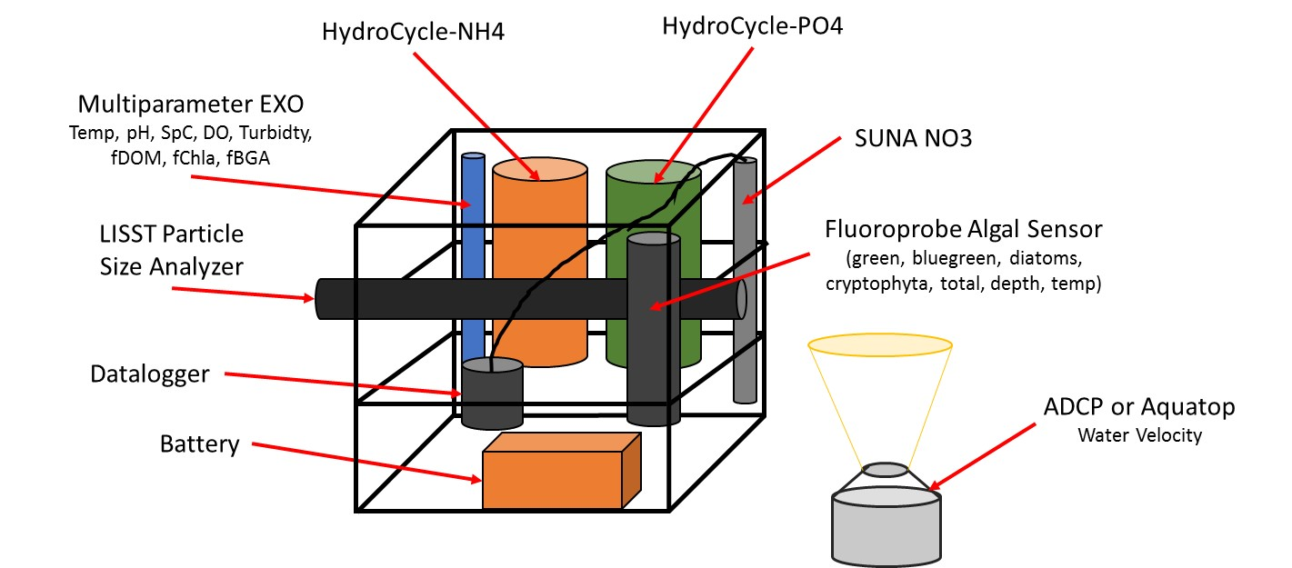

**Figure 1.** Cartoon of an instrument package that can be deployed to collect in situ, high frequency data related to dissolved and particulate material in the water column. Data collected over several weeks in tidal systems can capture changes in water quality associated with water entering versus exiting aquatic vegetation beds. Collection of discrete water samples provides additional information (e.g., phytoplankton enumeration, total dissolved nitrogen, particulate C and N content) and is used to validate these measurements

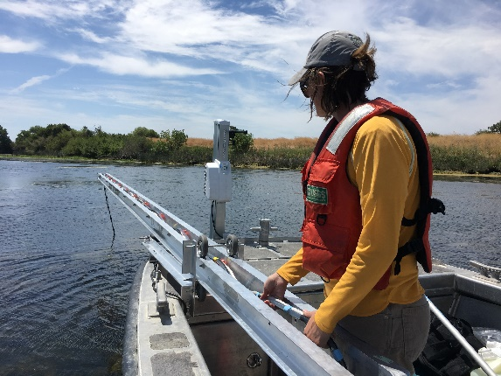 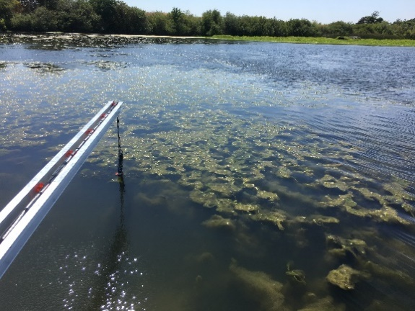 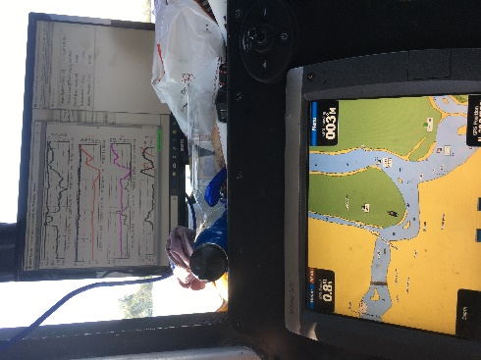

**Figure 2.** In addition to deploying instruments at a fixed location, the USGS CAWSC Biogeochemistry group has recently modified their boat-based mapping system to collect in situ water quality data and discrete samples at various depths in beds of dense aquatic vegetation while causing minimal disturbance. A high resolution CTD (conductivity, temperature, depth; sampling frequency 16/sec) sensor pumps water back to instruments on board that can measure parameters shown in Figure 1 (sampling frequency 1/sec), which can be viewed in real time on the boat to inform sample collection.

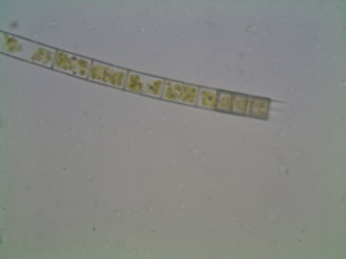 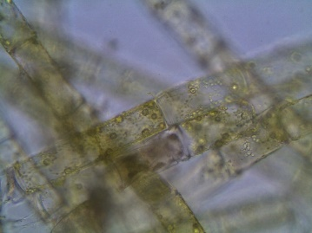 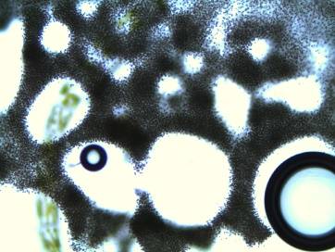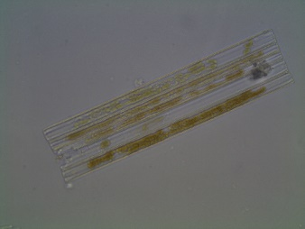 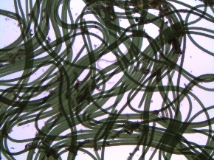 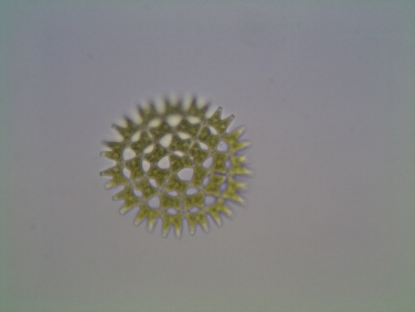 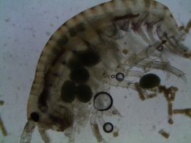

**Figure 3.** Preliminary sampling within and near invasive aquatic vegetation shows a diversity of algal species and zooplankton are present. Left to Right: *Aulacoseira, Oedogonium, Microcystis, Ulnaria, Oscillatoria, Pediastrum, Amphipod*. (photos from September 2017 by Kurt Carpenter)